**Assignment-1 | VIT Bhopal**

**Given a string str, return true if the str can be palindrome after deleting at most one character from it.**

**/*!**

**\* Copyright (c) 2020 Abhishek Srivastava**

**\*/**

**#include <bits/stdc++.h>**

**using namespace std;**

**#define ll long long int**

**bool isPallindrone(string str) {**

**string str2="";**

**for(int i=str.size()-1; i>=0; i++)**

**str2 += str[i];**

**return str2 == str;**

**}**

**void solve() {**

**string str; cin >> str;**

**if(str.size() <= 1) cout << "NO";**

**if(isPallindrone(str)) cout << "YES";**

**else cout << "NO";**

**}**

**int main(){**

**ios :: sync_with_stdio(false);**

**cin.tie(0);**

**solve();**

**return 0;**

**}**

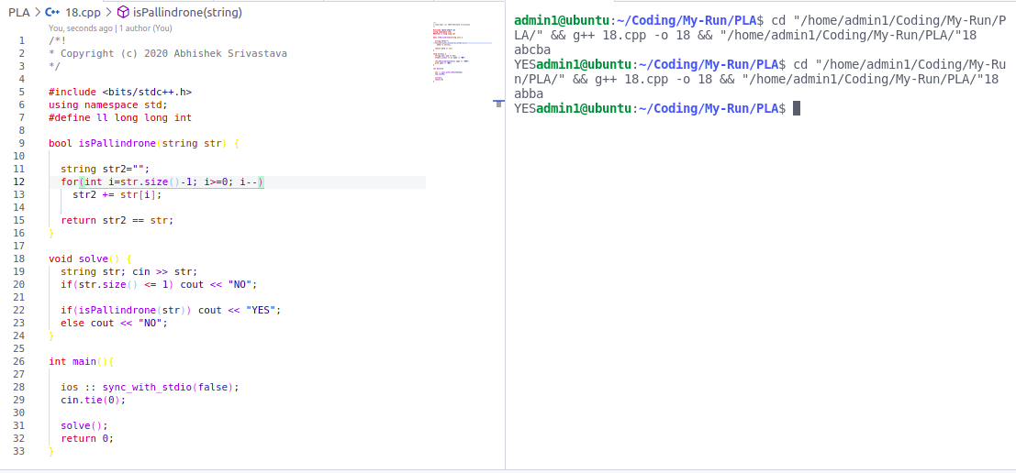

**LCM of Two Numbers while taking inputs**

**// LCM of Two Numbers**

**/*!**

**\* Copyright (c) 2020 Abhishek Srivastava**

**\*/**

**#include <bits/stdc++.h>**

**using namespace std;**

**#define ll long long int**

**int gcd(int a, int b) {**

**if(!b) return a;**

**else return gcd(b,a%b);**

**}**

**void solve() {**

**int n, m; cin >> n >> m;**

**cout << gcd(n, m) << "\n";**

**}**

**int main(){**

**ios :: sync_with_stdio(false);**

**cin.tie(0);**

**int t; cin >> t;**

**while(t--)**

**solve();**

**return 0;**

**}**

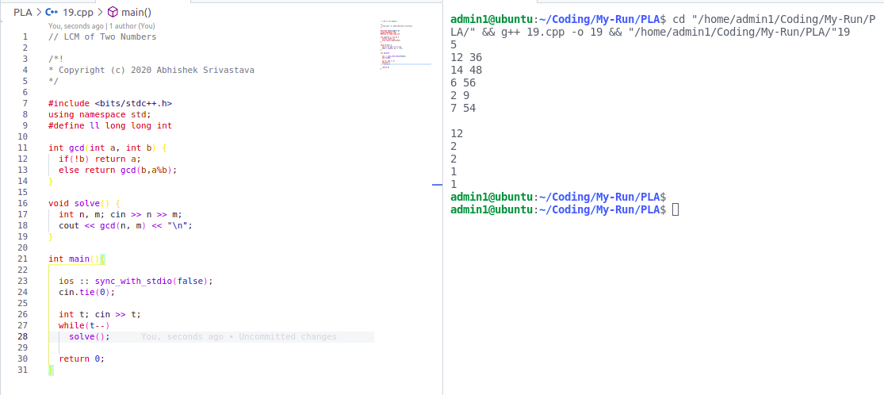

**Write Java Program to find out whether the year is a leap year**

**/*!**

**\* Copyright (c) 2020 Abhishek Srivastava**

**\*/**

**#include <bits/stdc++.h>**

**using namespace std;**

**#define ll long long int**

**void solve() {**

**int y; cin >> y;**

**if(y%4 == 0 || y%100 == 0) cout << "Leap year\n";**

**else cout << "Not a leap year\n";**

**}**

**int main(){**

**ios :: sync_with_stdio(false);**

**cin.tie(0);**

**int t; cin >> t;**

**while(t--)**

**solve();**

**return 0;**

**}**

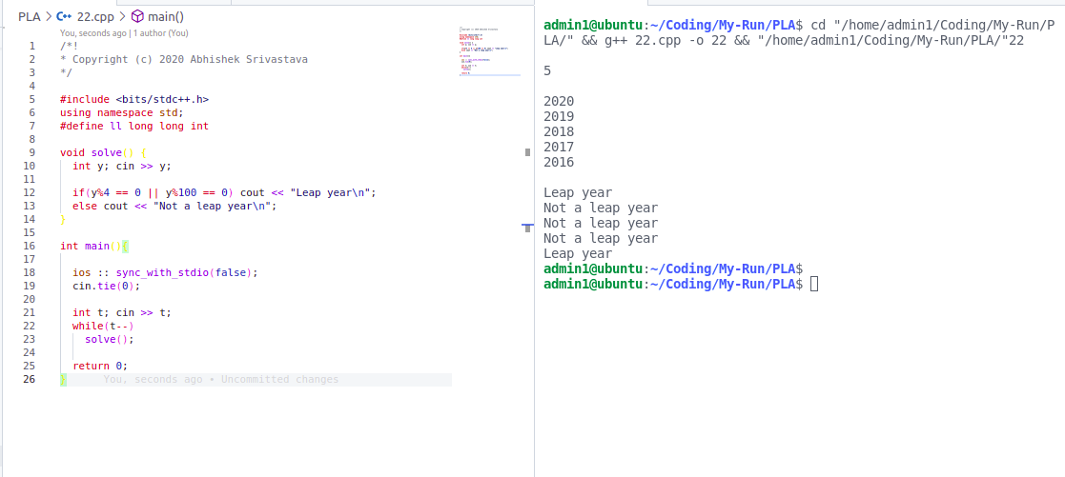

**You have been given numbers ‘x’ and ‘y’. Print all the numbers between 1 and x which follow the below**

**criteria**

**1. Should be co-prime with x**

**2. Should be divisible by ‘y’**

**/*!**

**\* Copyright (c) 2020 Abhishek Srivastava**

**You have been given numbers ‘x’ and ‘y’. Print all the numbers between 1 and x which follow the below**

**criteria**

**1. Should be co-prime with x**

**2. Should be divisible by ‘y’**

**\*/**

**#include <bits/stdc++.h>**

**using namespace std;**

**#define ll long long int**

**void solve() {**

**int x, y; cin >> x >> y;**

**for(int i=x; i<=y; i++)**

**if(i%y == 0 || __gcd(i, x) == 1) cout << i << ", ";**

**}**

**int main(){**

**ios :: sync_with_stdio(false);**

**cin.tie(0);**

**int t; cin >> t;**

**while(t--)**

**solve();**

**return 0;**

**}**

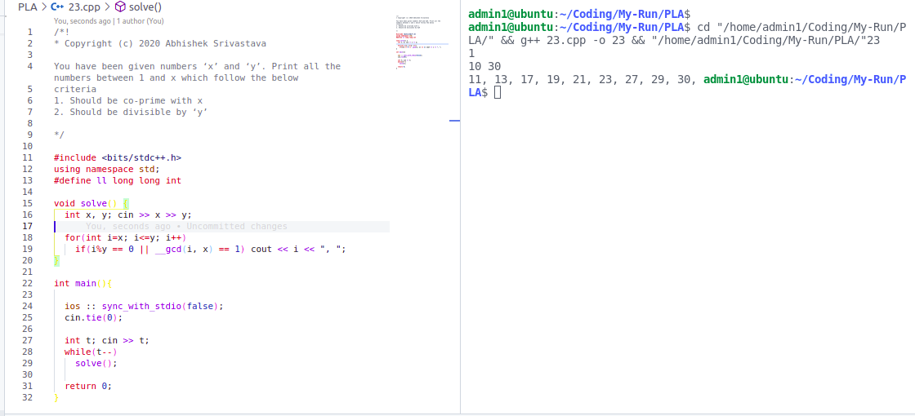

**Print those numbers ‘I’ between x and y which are the same when vertically inverted**

/*!

* Copyright (c) 2020 Abhishek Srivastava

Print those numbers ‘I’ between x and y which are the same when vertically inverted

*/

#include <bits/stdc++.h>

using namespace std;

#define ll long long int

bool sameVertically(int n) {

while(n > 0) {

int a = n%10;

if(a==1 || a==8) n = n / 10;

else return false;

}

return true;

}

void solve() {

int x, y; cin >> x >> y;

for(int i=x; i<=y; i++)

if(sameVertically(i)) cout << i << ", ";

}

int main(){

ios :: sync_with_stdio(false);

cin.tie(0);

int t; cin >> t;

while(t--)

solve();

return 0;

}



